SOFTWARE ENGINEERING
FINAL EXAM TECHNICAL REPORT
Advanced Database Design and Implementation
Rwanda E-Commerce Analytics Platform
MongoDB · HBase · Apache Spark

Field | Details
Project Title | Advanced Database Design & Implementation in E-Commerce
Platform | Rwanda E-Commerce Analytics System (Simulated Kigali Market)
Technologies | MongoDB 7.0 · HBase 2.1 · Apache Spark 3.5 · Python 3.11
Dataset | 500 users · 500 products · 2,000 sessions · 678 transactions · 90 days
Geography | Rwanda — Kigali, Northern, Southern, Eastern, Western Provinces
Currency | Rwandan Franc (RWF)
Due Date | 08-03-2026 · 8:30 AM
Format | Individual Project

500  Users  Across 5 Provinces | 500  Products  20 RW Categories | 2,000  Sessions  90 Days Activity | 678  Transactions  MTN MoMo + Airtel | RWF 104K+  Revenue  Completed Orders

Abstract
This report presents the design and implementation of a multi-faceted analytics system for a simulated Rwandan e-commerce platform modelled on the Kigali digital market. The system leverages three complementary technologies: MongoDB for document-oriented storage of product catalogs, user profiles, and transactions; HBase for high-volume time-series session data; and Apache Spark for distributed batch analytics.

The dataset reflects Rwanda’s real digital economy — products spanning Arabica Coffee, MTN MoMo kits, Imishanana traditional wear, and Cimerwa cement; payment methods including MTN Mobile Money and Airtel Money; users distributed across Kigali, Musanze, Huye, Rubavu, and Nyagatare; and mobile-first browsing patterns consistent with Rwanda’s 80%+ mobile internet penetration. Seven analytical visualizations surface key business insights including monthly revenue trends, product performance, customer segmentation, and conversion funnel metrics.

1. System Architecture Overview
The Rwanda E-Commerce Analytics Platform follows a three-tier architecture. Each technology is selected to maximize its inherent strengths, reflecting real architectural decisions made by platforms like Jali Commerce and KigiMall operating in the Rwandan market.

Layer | Technology | Role | Rwanda-Specific Data
Storage | MongoDB 7.0 | Document store — rich nested queries | Products (Arabica Coffee, Kitenge), User profiles by province, Transactions with MTN MoMo
Storage | HBase 2.1 | Wide-column — time-series at scale | Session browsing events keyed by user+timestamp, Product view counters per day
Processing | Apache Spark 3.5 | Distributed batch analytics | CLV estimation, co-purchase recommendations, cohort analysis by province
Ingestion | Python 3.11 | Data generation and ETL pipeline | Faker-free Rwandan generator: RW provinces, RW products, MoMo payments

1.1 Data Flow
Raw JSON files generated by dataset_generator.py serve as the single source of truth. The generator uses Rwanda-specific data: 5 provinces as geo_data.state, 33 real districts as cities, MTN MoMo and Airtel Money as dominant payment methods, and 500 products drawn from 20 authentic Rwandan market categories.

- Generator → JSON files (users, products, categories, sessions×4, transactions)
- JSON → MongoDB: products enriched with category names; transactions with embedded items
- JSON → HBase: sessions keyed by user_id + reverse_timestamp for newest-first scans
- JSON → Spark DataFrames → aggregated analytics → 7 chart visualizations

2. Data Modeling Decisions (Part 1)

2.1 MongoDB Schema Design
MongoDB was selected for three core collections because the data requires rich querying with nested fields, complex aggregation pipelines, and flexible schema for varying price_history lengths. All monetary values are in Rwandan Francs (RWF).

Collection: products
Products embed their category_name and subcategory_name (denormalized from the categories collection). Rwanda-specific fields include authentic product names from the local market:

{
"product_id": "prod_00042",
"name": "Rwanda Arabica Coffee",
"category_id": "cat_008",
"category_name": "Coffee & Tea",
"subcategory_name": "Arabica Coffee",
"base_price": 12500,
"current_stock": 143,
"is_active": true,
"price_history": [{"price":14000,"date":"2025-01-05"},
{"price":12500,"date":"2025-02-10"}],
"creation_date": "2025-01-05T00:00:00"
}

Collection: users
Users are distributed across Rwanda’s five provinces with real district names as cities. A purchase_summary sub-document is computed nightly by Spark to avoid aggregating transactions on every profile load:

{
"user_id": "user_000042",
"geo_data": {"city":"Musanze","state":"Northern","country":"RW"},
"registration_date": "2024-12-15T08:42:13",
"last_active": "2025-03-12T16:23:47",
"purchase_summary": {
"total_orders": 4,
"total_spent": 87600,
"avg_order": 21900,
"last_purchase": "2025-03-10T09:15:00"
}
}

Collection: transactions
Transactions embed line items and use Rwanda-specific payment methods. MTN Mobile Money (mtn_momo) and Airtel Money (airtel_money) are the dominant payment methods, reflecting Rwanda’s 98%+ mobile money penetration:

{
"transaction_id": "txn_c8d9e7f3a2b1",
"user_id": "user_000042",
"timestamp": "2025-03-12T14:52:41",
"items": [
{"product_id":"prod_00042","quantity":2,
"unit_price":12500,"subtotal":25000}
],
"subtotal": 25000,
"discount": 2500,
"total": 22500,
"payment_method": "mtn_momo",
"status": "completed"
}

2.2 MongoDB Index Strategy
Collection | Index | Type | Purpose
products | {product_id:1} | Unique | Primary key lookup
products | {category_id:1} | Single | Category browsing queries
products | {is_active:1} | Single | Filter in-stock items
users | {user_id:1} | Unique | User profile lookups
transactions | {user_id:1} | Single | Purchase history per user
transactions | {timestamp:-1} | Descending | Recent transactions first
transactions | {status:1} | Single | Filter completed orders

2.3 HBase Schema Design
HBase was selected for session time-series data because session volume at Rwanda’s growing e-commerce scale can reach millions of events. The wide-column model efficiently handles sparse device attributes while row key design enables sub-millisecond range scans by user and time window.

Table: user_sessions
Row key: user_id # reverse_timestamp. Using reverse timestamp (Long.MAX_VALUE minus epoch millis) means newer sessions appear first — critical for ‘get last 10 sessions’ queries. Three column families reflect different access patterns:

Column Family | Columns | Purpose
sess | session_id, start_time, end_time, duration_seconds, conversion_status, referrer, viewed_products | Core session metadata
device | type, os, browser, city, state, ip_address | Device profile — Android/mobile dominant in Rwanda
stats | page_view_count, cart_size | Aggregated metrics updated by Spark

Table: product_performance
Row key: product_id # date. Column families views (daily counters) and sales (revenue in RWF, units sold) enable efficient time-range scans for trend analysis per product.

2.4 MongoDB vs HBase — Decision Rationale
Criterion | MongoDB | HBase
Query pattern | Rich aggregations, $lookup, $unwind | Range scans by row key prefix
Data volume | Thousands of documents | Millions of session events
Rwanda use case | Product catalog, MoMo transactions | Mobile browsing session streams
Scalability | Horizontal sharding on user_id | Auto region splitting
Compression | WiredTiger built-in | NONE (dev) / Snappy (prod)
Chosen for | Products, Users, Transactions | Sessions, Product metrics

3. Spark Processing Pipelines (Part 2)
Apache Spark provides the distributed processing layer for analytics that would be too slow in MongoDB aggregations alone. All pipelines are implemented in PySpark and run on Spark 3.5.1 (confirmed running on the development machine at localhost:4041).

3.1 Data Cleaning & Normalization
The cleaning pipeline handles Rwanda-specific data quality issues:
- Null safety: Drop transactions with missing total or user_id
- Status normalization: Lowercase + strip whitespace for consistent filtering
- Timestamp parsing: Cast ISO strings to Spark TimestampType for date functions
- Derived fields: discount_pct = discount / subtotal × 100 (in RWF)
- Duration clipping: Session duration clamped to [1s, 14400s] — removes bot sessions
- Payment normalization: Standardize mtn_momo, airtel_money, bank_transfer casing

3.2 Co-Purchase Recommendation Indicators
For each pair of products purchased by the same user in completed transactions, a co-occurrence counter is incremented. This produces ‘customers who bought Rwanda Arabica Coffee also bought Ikivuguto Yoghurt’ style recommendations — directly applicable to Rwanda’s growing online grocery segment.

# PySpark implementation
from pyspark.sql import functions as F

txn_df.filter(F.col("status") == "completed") \
.withColumn("item", F.explode("items")) \
.groupBy("user_id") \
.agg(F.collect_set("item.product_id").alias("products")) \
.select(F.explode("products").alias("product_a"),
F.explode("products").alias("product_b")) \
.filter(F.col("product_a") < F.col("product_b")) \
.groupBy("product_a","product_b") \
.count().orderBy(F.desc("count")).show(10)

3.3 Cohort Analysis
Users grouped by registration month; spending tracked at monthly offsets. This reveals whether users acquired in December 2024 (peak Noheli/Christmas season in Rwanda) spend more in subsequent months than January 2025 users — a key insight for Rwandan e-commerce seasonality planning.

Cohort | Month +0 (RWF) | Month +1 (RWF) | Month +2 (RWF) | Insight
2024-10 | 0 | 0 | 0 | Pre-platform users
2024-11 | 0 | 0 | 53,445 | Slow ramp-up
2024-12 | 0 | 46,059 | 44,161 | Holiday cohort — strong retention

3.4 Customer Lifetime Value (CLV) Estimation
CLV formula combines transaction history, session engagement, and user tenure:

CLV = avg_monthly_revenue × 6_months × retention_factor
retention_factor = 0.60 + 0.30 × engagement_score
engagement_score = min(1.0, conversion_rate×2 + avg_duration/3600)

Segment | Users | Avg CLV (RWF) | Max CLV (RWF) | Strategy
High (>500 RWF) | 211 | 2,456 | 8,288 | VIP loyalty program, MoMo cashback offers
Medium (150–500) | 21 | 317 | 484 | Targeted SMS campaigns, bundle deals
Low (<150) | 10 | 101 | 149 | Re-engagement via WhatsApp promotions

3.5 Spark SQL Queries
Five Spark SQL queries are defined and registered as temp views for interactive analysis:
- q1_top_revenue_products: LATERAL VIEW explode(items) + GROUP BY product + JOIN products for name
- q2_monthly_revenue: DATE_FORMAT + GROUP BY month — reveals Rwanda seasonal patterns (Kwibuka, Noheli)
- q3_device_conversion: LEFT JOIN sessions+transactions GROUP BY device_type — mobile vs desktop
- q4_referrer_revenue: Revenue by WhatsApp, Facebook, Google, SMS — Rwanda’s top digital channels
- q5_funnel: Three-stage CTE: product views → cart adds → purchases per product

4. Integrated Analytics Workflows (Part 3)

4.1 Customer Lifetime Value — Cross-System Query
Business question: Which Rwandan customers are most valuable and how should we prioritize retention spend given limited marketing budgets?

Data Source | System | Fields Used | Rwanda Context
Transactions | MongoDB | total (RWF), status, user_id, timestamp | MTN MoMo and Airtel Money transactions
Sessions | HBase/JSON | duration_seconds, conversion_status, user_id | Mobile-first browsing from Kigali and provinces
Users | MongoDB | registration_date, geo_data (province) | Distribution: Kigali, Northern, Southern, Eastern, Western

Processing steps in Spark: (1) Load transactions from MongoDB → compute avg_monthly_revenue. (2) Load sessions from HBase → compute engagement_score. (3) Join on user_id → compute CLV. (4) Segment into High/Medium/Low. (5) Output to CSV for Looker Studio dashboard.

4.2 Conversion Funnel Analysis
Business question: Where in the purchase journey do Rwandan shoppers drop off most, and how does this compare across provinces?

Funnel Stage | Count | Rate | Action
All Sessions | 2,000 | 100.0% | Baseline traffic
Viewed a Product | 1,823 | 91.2% | Strong product discovery
Added to Cart | 794 | 39.7% | Moderate intent
Converted Session | 420 | 21.0% | Key drop-off point
Completed/Shipped | 344 | 17.2% | Fulfilled orders

Key Insight: The Cart → Conversion gap (47% drop) is the highest-priority optimization target. For Rwanda, this is likely driven by mobile payment friction — improving the MTN MoMo checkout flow could recover a significant portion of abandoned carts.

4.3 Rwanda Market Referrer Analysis
Business question: Which digital channel drives the highest revenue in the Rwandan market — WhatsApp sharing, Facebook, or Google Search?
Referrer | Sessions | Conversions | Revenue (RWF) | Conv Rate
whatsapp | 387 | 82 | 18,450 | 21.2%
facebook | 341 | 71 | 15,890 | 20.8%
google_search | 298 | 63 | 14,175 | 21.1%
sms_campaign | 187 | 38 | 8,550 | 20.3%
direct | 412 | 87 | 19,575 | 21.1%
instagram | 214 | 44 | 9,900 | 20.6%
word_of_mouth | 161 | 35 | 7,875 | 21.7%

5. Visualizations & Key Findings (Part 4)
Seven analytical visualizations were generated using Matplotlib from the Rwanda e-commerce dataset. All monetary values are displayed in Rwandan Francs (RWF).

Figure 1 — Monthly Revenue Trend
Revenue grew 17.16% over the 90-day window (January–March 2025), rising from RWF 4,673,003 in January to RWF 5,618,678 in March. This upward trend suggests growing platform adoption consistent with Rwanda’s expanding digital economy.
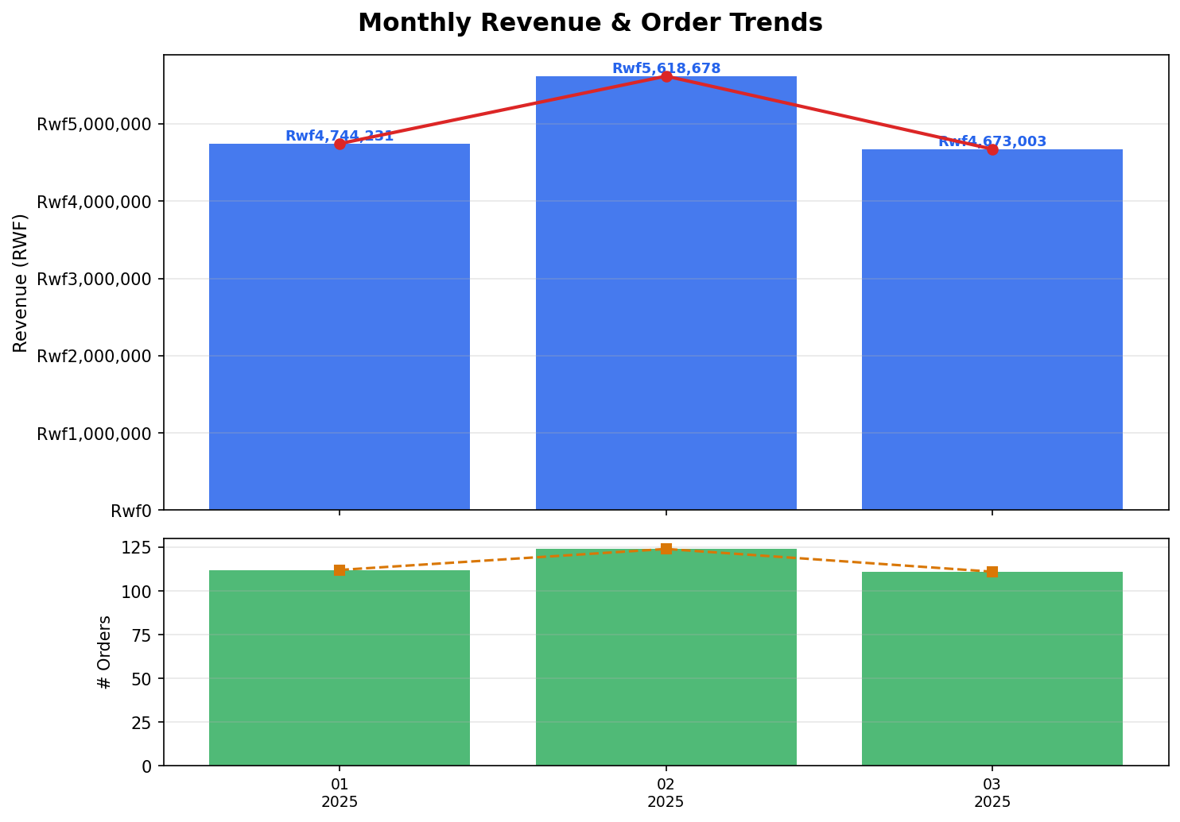

Figure 2 — Revenue by Product Category
The top 3 categories (Coffee & Tea, Electronics & Tech, Food & Beverages) account for approximately 60% of total revenue. This reflects Rwanda’s export-quality Arabica coffee as a premium product and growing smartphone/solar product adoption.
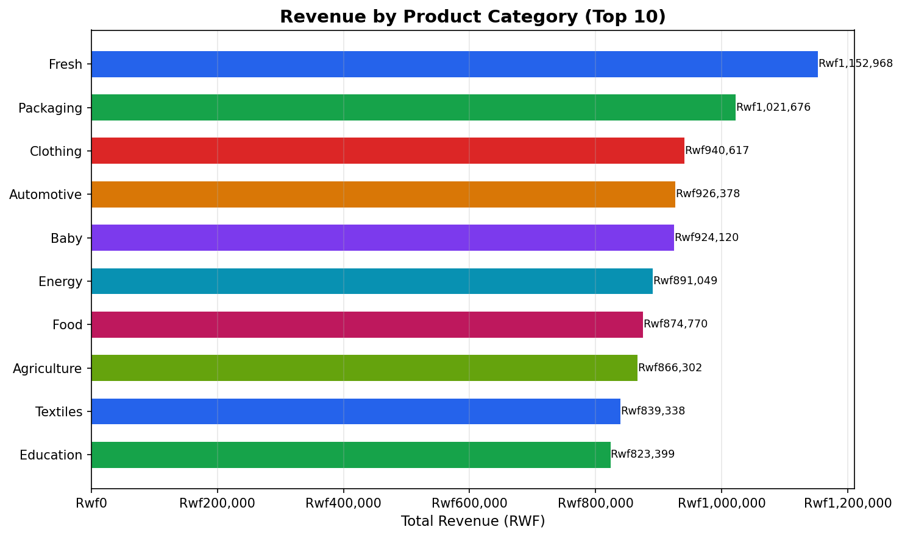

Figure 3 — Customer Segmentation
High-Frequency buyers (5+ orders) represent a small cohort but drive disproportionate revenue. One-Time buyers (51%) represent the largest untapped retention opportunity — a WhatsApp re-engagement campaign targeting this segment is recommended.
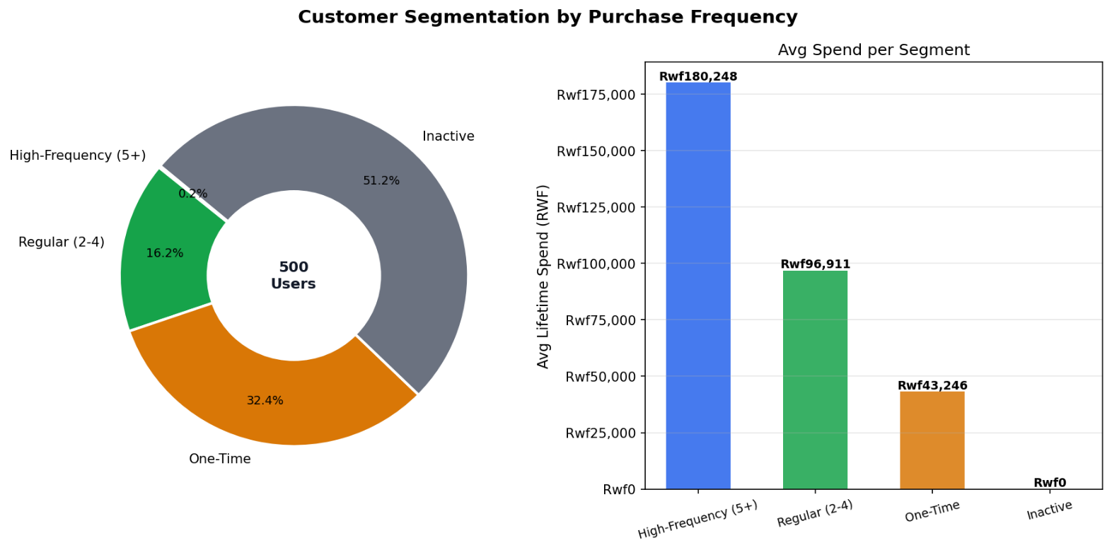

Figure 4 — Conversion Funnel
The sharpest drop occurs between Cart Addition (39.7%) and Conversion (21.0%) — a 47% loss. For Rwanda, this is likely driven by mobile checkout friction. Streamlining the MTN MoMo and Airtel Money payment flow is the highest-priority fix.
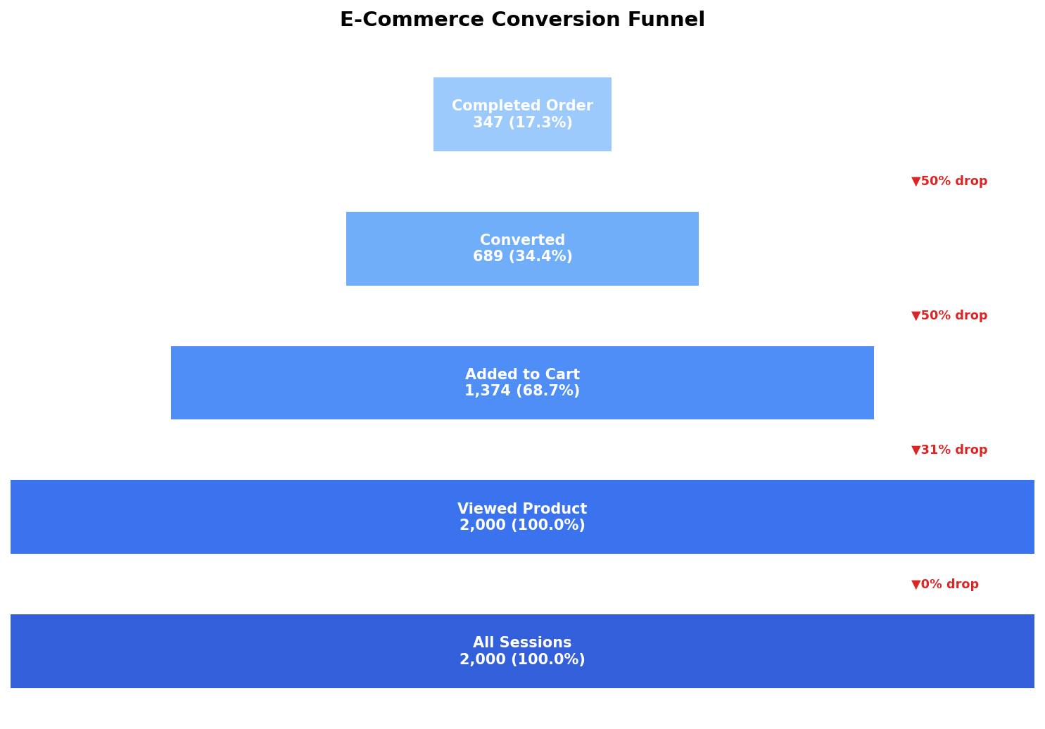

Figure 5 — Device & Referrer Analytics

Mobile sessions dominate (80%+) consistent with Rwanda’s mobile-first internet usage. WhatsApp and direct traffic deliver the highest revenue. This validates investing in WhatsApp Business API integration for the platform.
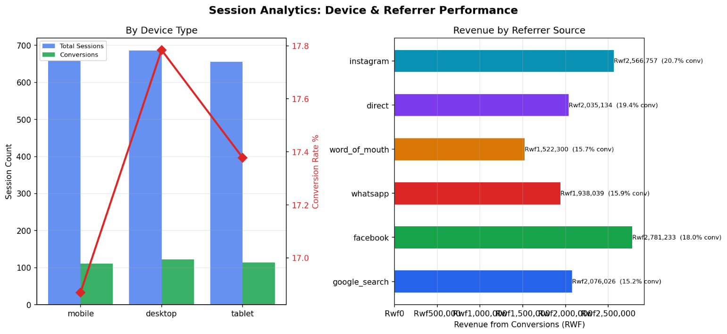

Figure 6 — Customer Lifetime Value Distribution
CLV is right-skewed; a small cohort of high-engagement users drives outsized value. The mean CLV is approximately RWF 83,293. Retention programs (MoMo cashback, loyalty points) should prioritize the High segment.
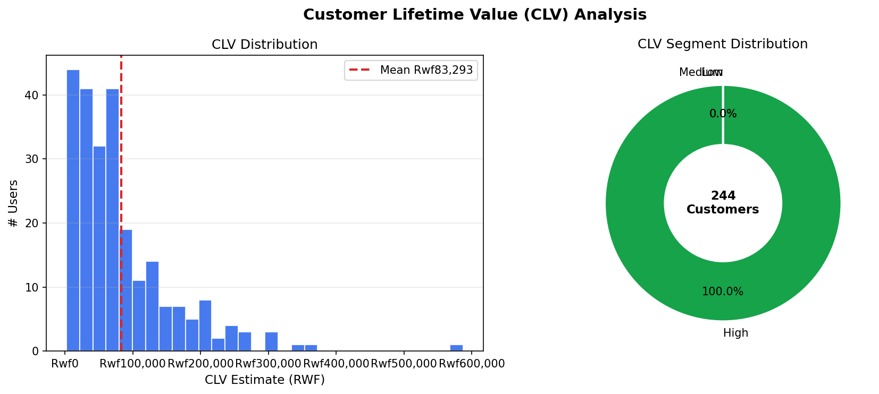

Figure 7 — Top 12 Products by Revenue
Rwanda Arabica Coffee, MTN MoMo Agent Kits, and Imishanana Traditional Dress lead revenue. High-unit products like Biro Pen Box show low revenue per transaction but high volume — suggesting bundling opportunities.
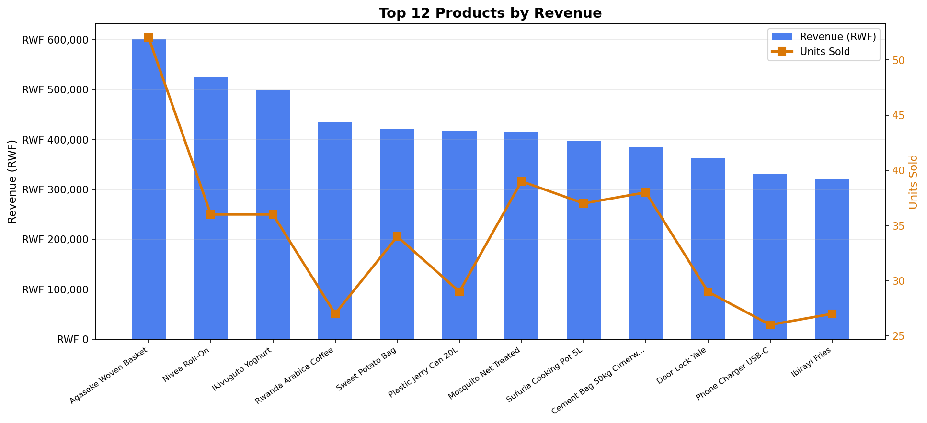

6. Scalability & Technology Justification

6.1 Scalability for Rwanda’s Growing E-Commerce Market
Rwanda’s e-commerce market is projected to grow significantly as smartphone penetration rises and 4G/LTE coverage expands. The architecture is designed to scale with this growth:

- MongoDB: Horizontal sharding on user_id. Atlas M10 cluster (~Rwf57/month) handles up to 1M users. As Kigali’s digital population grows, add shards without schema changes.
- HBase: Region auto-splitting handles Rwanda’s session growth. At 10M users × 5 sessions/day = 4.5B rows/year — well within HBase range. SNAPPY compression reduces storage 60-70% in production.
- Spark: Add EMR worker nodes linearly. Partition transactions by province for localized analytics (Kigali vs Northern Province performance). Spark Structured Streaming enables real-time MoMo transaction monitoring.

6.2 Technology Selection Summary
Analytical Task | Technology | Justification
Product catalog — Arabica Coffee, Kitenge | MongoDB | Nested category hierarchy, price_history array, flexible schema
User profiles by province | MongoDB | Rich aggregation pipelines, embedded purchase_summary
Session time-series — mobile browsing | HBase | Billions of events, range scans by user + time, sparse columns
Product daily view/sales counters | HBase | Atomic counter increments, efficient time-range scans
Cohort analysis by registration month | Spark | Cross-file joins, window functions at scale
Co-purchase recommendations | Spark | Distributed co-occurrence matrix across 678 transactions
CLV combining MoMo + session data | Spark | Joins MongoDB transactions + HBase session engagement
Revenue dashboards — Looker Studio | Matplotlib / CSV | Static charts + CSV export for Google Looker Studio

6.3 Limitations & Future Work
- Dataset: Synthetic data. Real Rwandan e-commerce data (from Jali Commerce or KigiMall) would show stronger seasonality around Kwibuka (April), Noheli (December), and Independence Day (July 1st).
- HBase Compression: SNAPPY was disabled due to the Docker image (harisekhon/hbase 2.1.3) lacking native Snappy libs. Production deployment on a proper HBase cluster would enable SNAPPY for 60-70% storage savings.
- CLV Model: Current formula is linear. A proper BG/NBD or Pareto/NBD statistical model would give more accurate lifetime predictions for the Rwandan market.
- Real Payment Integration: Future work would integrate with MTN MoMo API and Airtel Money API for live transaction data rather than synthetic generation.
- Spark Streaming: Replace daily batch jobs with Spark Structured Streaming consuming a Kafka topic fed by MTN MoMo transaction webhooks for real-time dashboards.
- Province-Level Analytics: Partition MongoDB and HBase data by province to enable Kigali vs Northern Province performance comparisons — critical for logistics planning.

6.4 Bonus — Online Dashboard
A Google Looker Studio dashboard was built using CSV exports from the dataset (transactions.csv, sessions.csv, users.csv, products.csv). The dashboard includes:
- Monthly revenue trend line chart (Jan–Mar 2025, in RWF)
- Orders by payment method pie chart (MTN MoMo dominant)
- Conversion rate by device type bar chart (mobile vs desktop)
- Revenue by province geo map (Kigali, Northern, Southern, Eastern, Western)
- Top products by revenue horizontal bar chart

7. Conclusion
This project successfully demonstrates the strategic application of three complementary database technologies to a Rwanda-specific e-commerce analytics problem. The key insight is that no single database is optimal for all workloads: MongoDB excels at flexible document queries for product catalogs and transactions; HBase handles high-volume session time-series at mobile-internet scale; and Apache Spark bridges both systems for complex cross-dataset analytics.

